# Lab 1. Download MySQL installer for windows

## Download the MySQL installer

1. Download the MySQL installer from the following

<https://dev.mysql.com/downloads/installer/>

1. Click on download

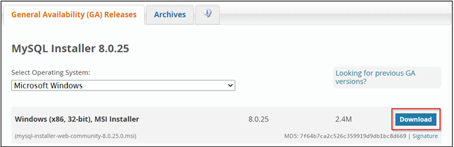

1. Select “No thanks, just start my download”

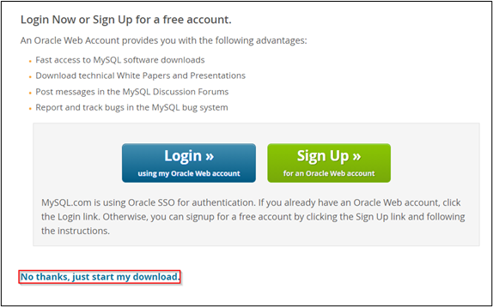

1. Go to Downloads folder and double click on the package you just downloaded

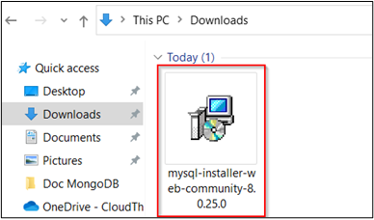

1. Select Server only and click on Next

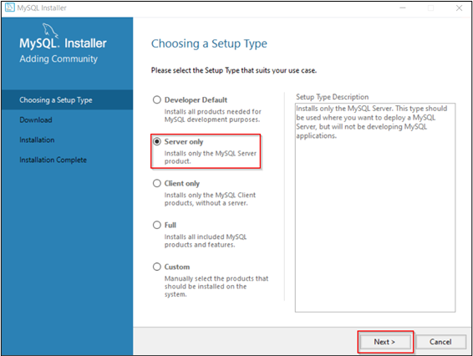

1. Click on Execute

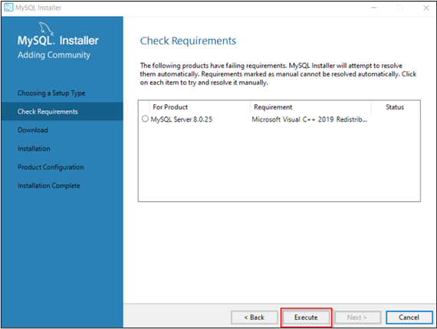

1. If prompted Accept the license agreement and install it or skip to step 9

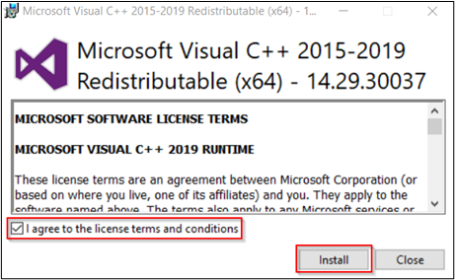

1. Click on Next and Make sure the status of Visual C++ should be Installed and click on Next

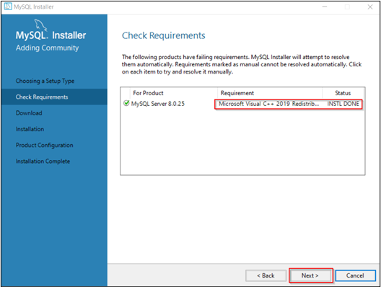

1. Click on Execute

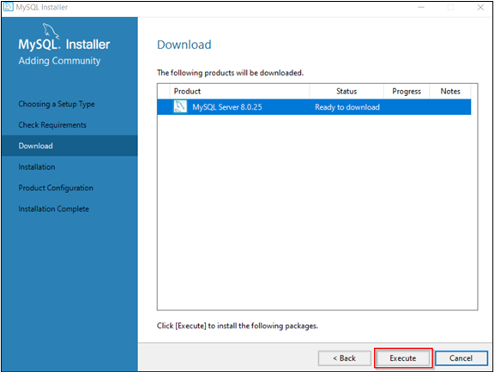

1. Once the status of downloading is labeled as Downloaded, click on Next

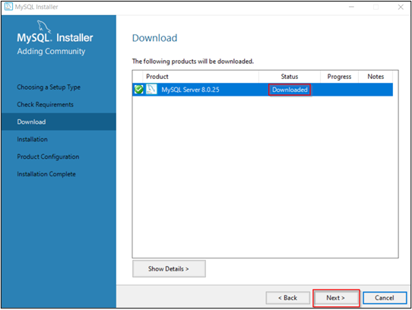

1. Click on Execute

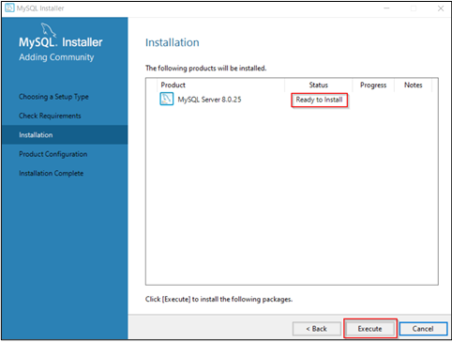

1. Click on Next

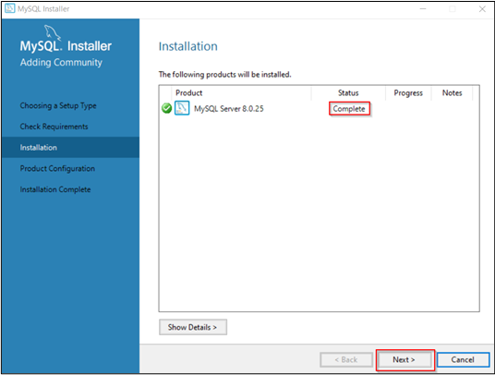

1. Click on “Show Advanced and Logging Options” and click on Next

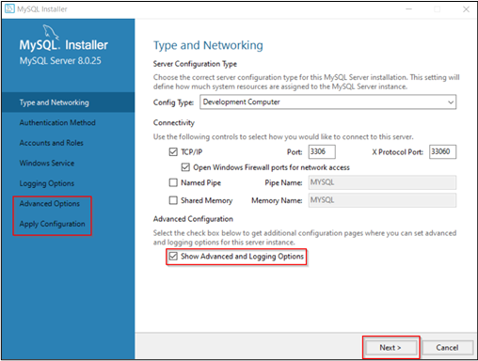

1. In Authentication method, select “Use Strong Password Encryption for Authentication” and click on Next

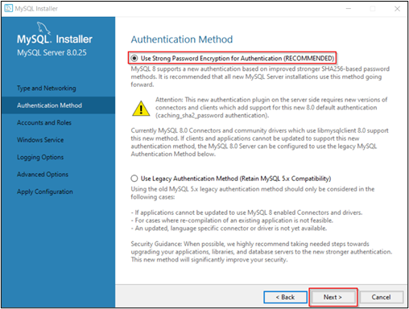

1. Enter a strong password for MySQL root user and Click on Next

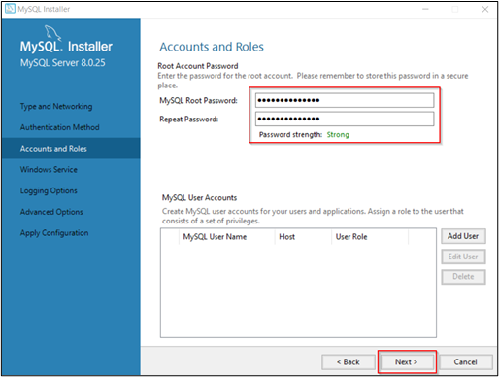

1. Select the following setting and click on Next

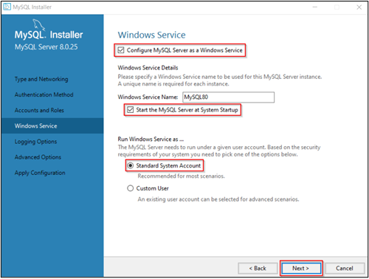

1. Click on Next, Next and Execute the configuration

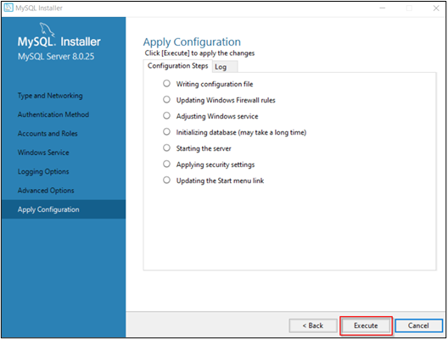

1. Once configuration is successfully completed, click on Finish

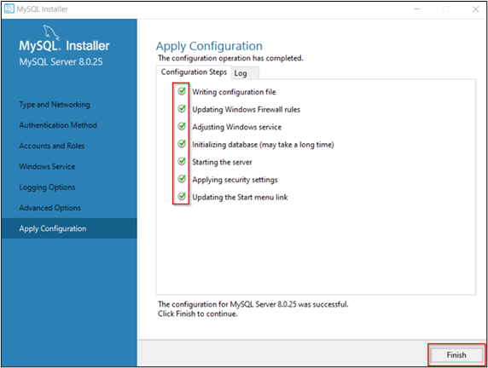

1. Product configuration is completed then click on next
2. Copy the logs to clipboard and save it in a file, Click on Finish

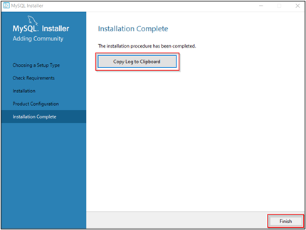

## Lab 2. Structured Query Language

### 1. Open MySQL Command Line

1. Search “mysql 8.0 command line” and click on open

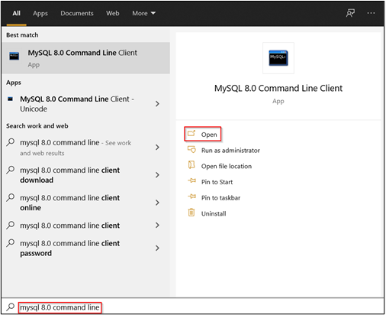

1. Enter the MySQL root password that you are set in Lab-1

### 2. Creating Database and Tables in MySQL

### 

### Create a database and named it as JTMK_DB

CREATE DATABASE JTMK_DB;

USE JTMK_DB;

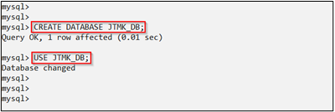

1. Create two tables as shown below

#First_Table

CREATE TABLE DEPARTMENT

(DEPT_NO CHAR(3) NOT NULL,

DEPT_NAME VARCHAR(36),

DEPT_LOCATION CHAR(16),

 PRIMARY KEY (DEPT_NO));

#Second_Table

CREATE TABLE EMPLOYEE

(EMP_NO VARCHAR(10)NOT NULL,

EMP_FIRSTNAME VARCHAR(15),

 EMP_LASTNAME VARCHAR(15),

EMP_PHONENO CHAR(4),

EMP_HIREDATE DATE,

SALARY DECIMAL(9,2),

DEPT_NO CHAR(3),

PRIMARY KEY (EMP_NO),

FOREIGN KEY (DEPT_NO) REFERENCES DEPARTMENT(DEPT_NO));

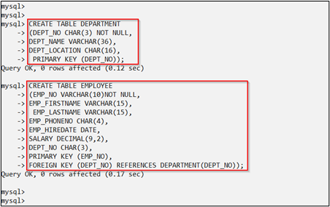

1. Check the tables description that you just created

SHOW TABLES;

DESC DEPARTMENT;

DESC EMPLOYEE;

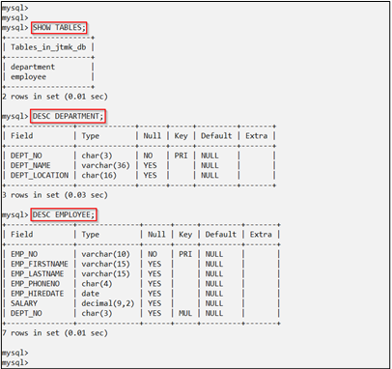

1. Alter the Employee table

ALTER TABLE EMPLOYEE

ADD EMP_ADDRESS VARCHAR(30);

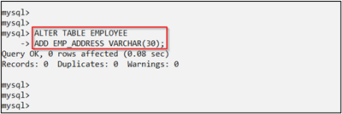

1. Alter the EMPLOYEE table by changing the data type of the column named EMP_PHONENO CHAR(4) to EMP_PHONENO INT(11)

ALTER TABLE EMPLOYEE

MODIFY EMP_PHONENO INT(11);

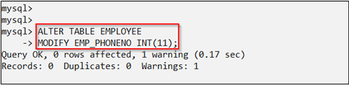

1. Alter the EMPLOYEE table by changing the column name to the new name of column EMP_PHONENO INT to EMP_PHONE INT and check the description of the altered table

ALTER TABLE EMPLOYEE

CHANGE EMP_PHONENO EMP_PHONE INT(11);

DESC EMPLOYEE;

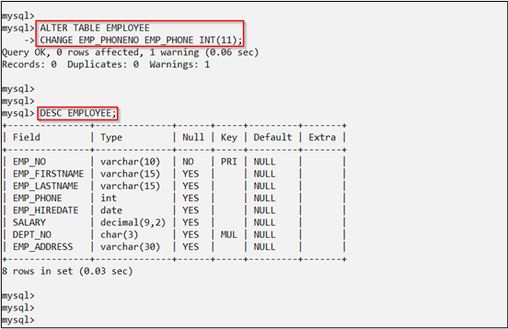

1. Drop table EMPLOYEE and database JTMK_DB

DROP TABLE EMPLOYEE;

DROP DATABASE JTMK_DB;

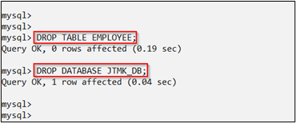

1. Check the list of databases available

SHOW DATABASES;

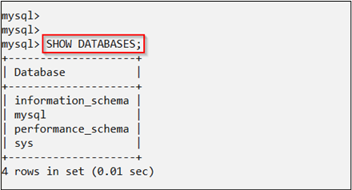

### EXERCISES

A database named <your_name>_DB will be developed by an application software house company. There are 6 tables in the database. Relationship scheme for the tables is as below:

Student(**StudID**, StudName,StudAddress,StudBirthDate,CourseID); Course(**CourseID**,CourseName,LectID);

Lecturer(**LectID**, LectName,LectTelNo,DepartID);

 Subject(**SubID**, SubName); Department**(DepartID**, DepartName);

Stud_Sub (**StudSubID**,StudID,SubID, Mark,Grade)

*(Primary Key showed by underlined and bold while in italic and dotted lined is Foreign Key)*

Data Dictionary for the tables is as below:

|  |  |  |  |  |
| --- | --- | --- | --- | --- |
| **Tables Name** | **Attributes Name** | **Data Types** | **PK/FK** | **FK refer to** |
| **STUDENT** | StudID | VARCHAR(5) | PK |  |
| StudName | VARCHAR(20) |  |  |
| StudAddress | VARCHAR(30) |  |  |
| StudBirthDate | DATE |  |  |
| CourseID | VARCHAR(5) | FK | COURSE |
| **COURSE** | CourseID | VARCHAR(5) | PK |  |
| CourseName | VARCHAR(10) |  |  |
| LectID | VARCHAR(5) | FK | LECTURER |
| **LECTURER** | LectID | VARCHAR(5) | PK |  |
| LectName | VARCHAR(20) |  |  |
| LectTelNo | INT(10) |  |  |
| DepartID | VARCHAR(5) | FK | DEPARTMENT |
| **DEPARTMENT** | DepartID | VARCHAR(5) | PK |  |
| DepartName | VARCHAR(30) |  |  |
| **SUBJECT** | SubID | VARCHAR(5) | PK |  |
| SubName | VARCHAR(20) |  |  |
| **STUD_SUB** | StudSubID | VARCHAR(5) | PK |  |
| StudID | VARCHAR(5) | FK | STUDENT |
| SubID | VARCHAR(5) | FK | SUBJECT |
| Mark | INT(3) |  |  |
| Grade | CHAR(2) |  |  |

## Lab 3. Structured Query Language

Activity Outcome: Able to apply SQL commands to manipulate data.

EXAMPLES OF DATA MANIPULATION LANGUAGE (DML) COMMANDS

DEPARTMENT

|  |  |  |
| --- | --- | --- |
| DEPT_NO | DEPT_NAME | DEPT_LOCATION |
| D01 | JTMK | CAMPUS A |
| D02 | JKE | CAMPUS A |
| D03 | JPA | CAMPUS B |
| D04 | JP | CAMPUS B |
| D05 | JKM | CAMPUS A |
| D06 | JKA | CAMPUS A |
| D07 | JKP | CAMPUS A |

EMPLOYEE

|  |  |  |  |  |  |  |  |
| --- | --- | --- | --- | --- | --- | --- | --- |
| EMP_NO | EMP_FIRSTNAME | EMP_LASTNAME | EMP_PHONE | EMP_HIREDATE | SALARY | DEPT_NO | EMP_ADDRESS |
| EMP10 00001 | AHMAD | HAKIMI | 0126747087 | 01/01/2011 | 200000.00 | D01 | TAMAN SRI PUTRA,  BANTING |
| EMP10 00002 | JULIA | JOHAN | 0125432313 | 01/04/2011 | 50000.00 | D01 | TAMAN KEMUNING  ,IPOH |
| EMP10 00003 | SETH | COHAN | 0198767898 | 09/02/2012 | 20000.00 | D03 | TAMAN BUDIMAN,  KANGAR |
| EMP10 00004 | RAYMOND | LIM | 0147839477 | 03/06/2012 | 40000.00 | D05 | TAMAN ANGGERIK  ,CHERAS |
| EMP1000005 | HANITH | EMELIO | 0123457689 | 03/06/2012 | 200000.00 | D05 | TAMAN HILLCRES  T,KL |
| EMP10 00006 | SATHINI | RAJU | 0187992873 | 03/06/2012 | 700000.00 | D02 | TAMAN JAYA,  IPOH |

#### INSERT INTO Statement

1. The first form does not specify the column names where the data will be inserted,

only their values:

INSERT INTO table_name

VALUES (value1, value2, value3,);

Example(Refer Lab 2):

INSERT INTO DEPARTMENT

VALUES ('D01', 'JTMK', 'CAMPUS A');

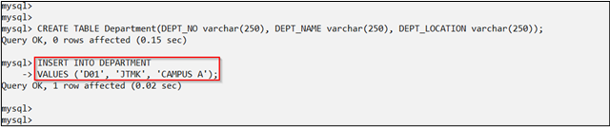

1. The second form specifies both the column names and the values to be inserted:

INSERT INTO table_name (column1, column2, column3,)

VALUES (value1, value2, value3,);

Example (Refer Lab 2):

INSERT INTO EMPLOYEE (EMP_NO,EMP_FIRSTNAME,EMP_LASTNAME,EMP_PHONE,EMP_HIREDATE,SALA RY,DEPT_NO)VALUES ('EMP1000001', 'AHMAD', 'HAKIMI',0126747087, '2011/01/01',200000.00, 'D01');

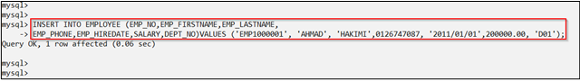

#### Insert all the data below by using the pervious exercise on Lab 2

STUDENT

|  |  |  |  |  |
| --- | --- | --- | --- | --- |
| StudID | StudName | StudAddress | StudBirthDate | CourseID |
| IT101 | Aminah | Perak | 19/10/1990 | C1000 |
| IT102 | Joe | Selangor | 13/08/1990 | C1000 |
| IT103 | Mona | Perak | 23/07/1991 | C1000 |
| IT104 | Husna | Melaka | 09/05/1990 | C1002 |
| IT105 | Lingling | Melaka | 07/07/1989 | C1004 |
| IT106 | Maniam | Penang | 01/12/1989 | C1003 |

COURSE

|  |  |  |
| --- | --- | --- |
| CourseID | CourseName | LectID |
| C1000 | Software Development | L1001 |
| C1001 | Artificial Intelegence | L1003 |
| C1002 | Database | L1002 |
| C1003 | Interactive Multimedia | L1010 |
| C1004 | Networking | L1005 |

DEPARTMENT

|  |  |
| --- | --- |
| DepartID | DepartName |
| D1000 | Software Engineering |
| D1001 | Industrial Computing |
| D1002 | Comp System & Comm |
| D1003 | Interactive Multimedia |
| D1004 | Management |

LECTURER

|  |  |  |  |
| --- | --- | --- | --- |
| LectID | LectName | LectTelNo | DepartID |
| L1001 | Mokhsin | 0178908767 | D1000 |
| L1002 | Sheima | 0192299090 | D1000 |
| L1003 | Raju | 0101989909 | D1001 |
| L1004 | Zulkifli | 0123984902 | D1000 |
| L1005 | Rahmad | 0145667389 | D1002 |
| L1006 | Naina | 0143662738 | D1001 |
| L1007 | Junaida | 0135557728 |  |
| L1008 | Hamid |  | D1004 |
| L1009 | Chong |  |  |
| L1010 | Sam |  | D1003 |

SUBJECT

|  |  |
| --- | --- |
| SubID | SubName |
| SC100 | Programming Technique |
| SC101 | System Development |
| SC102 | Database |
| SC103 | Object Oriented |
| SC104 | Multimedia System |
| SC105 | Logic Programming |

STUD_SUB

|  |  |  |  |  |
| --- | --- | --- | --- | --- |
| StudSubID | StudID | SubID | Mark | Grade |
| SS100 | IT101 | SC100 | 60 | B |
| SS101 | IT102 | SC100 | 85 | A |
| SS102 | IT103 | SC100 | 90 | A |
| SS103 | IT104 | SC103 | 76 | B |
| SS104 | IT105 | SC103 | 56 | C |
| SS105 | IT106 | SC104 | 65 | B |
| SS106 | IT101 | SC104 | 45 | D |
| SS107 | IT102 | SC104 | 98 | A |
| SS108 | IT103 | SC101 | 67 | B |
| SS109 | IT104 | SC101 | 54 | C |
| SS110 | IT105 | SC101 | 87 | A |
| SS111 | IT106 | SC101 |  | A |

1. UPDATE Statement

UPDATE table_name

SET column1=value, column2=value2, WHERE some_column=some_value;

Example (REFER LAB 2):

UPDATE EMPLOYEE

SET EMP_ADDRESS='TAMAN SRI PUTRA,BANTING' WHERE EMP_NO='EMP1000001';

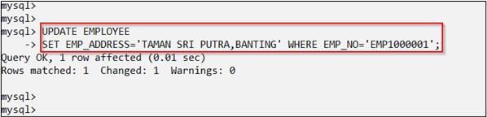

1. DELETE Statement

DELETE FROM table_name

WHERE some_column=some_value;

Example (REFER LAB 2):

DELETE FROM EMPLOYEE

WHERE EMP_NO='EMP1000001';

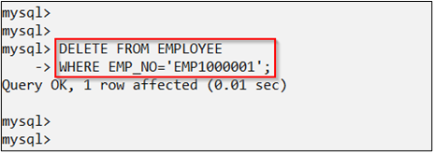

1. SELECTING DATA Statement
2. Select specific column:

SELECT column_name(s)

FROM table_name;

Example (REFER LAB 2):

SELECT DEPT_NO,DEPT_NAME FROM DEPARTMENT;

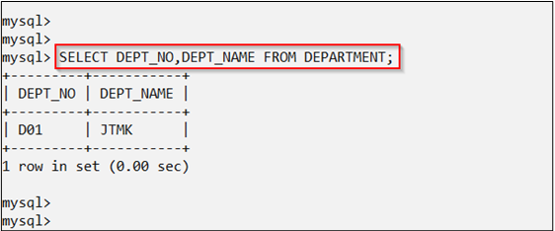

1. Select all columns:

SELECT * FROM table_name;

Example (REFER LAB 2):

SELECT * FROM DEPARTMENT;

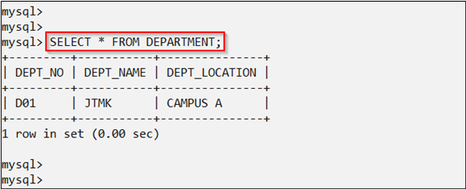

1. SELECT-FROM-WHERE Statement

SELECT column_name(s) FROM table_name

WHERE column_name operator value;

Example (REFER LAB 2)

SELECT DEPT_NO,DEPT_NAME FROM DEPARTMENT

WHERE DEPT_NO = 'D01';

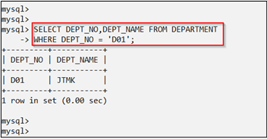

Comparison Operators:

|  |  |  |
| --- | --- | --- |
| Operator | Purpose | Example |
| = | Equality test. | SELECT * FROM EMPLOYEE WHERE EMP_NO ='EMP1000001'; |
| <>  *!=*  *!>*  *!<* | Not Equal To  *Not Equal To (not ISO standard)*  *Not Greater Than (not ISO standard)*  *Not Less Than (not ISO standard)* | SELECT * FROM EMPLOYEE WHERE DEPT_NO <> 'D01'; |
| > | Greater than | SELECT EMP_NAME,DEPT_NO FROM EMPLOYEE WHERE EMP_SALARY > 1000000.00 |
| < | Less than | SELECT EMP_NAME,DEPT_NO FROM EMPLOYEE WHERE EMP_SALARY < 1000000.00 |
| >= | Greater Than or equal to | SELECT EMP_NAME,DEPT_NO FROM EMPLOYEE WHERE EMP_SALARY >= 1000000.00 |
| <= | Less than or equal to | SELECT EMP_NAME,DEPT_NO FROM EMPLOYEE WHERE EMP_SALARY <= 1000000.00 |

1. LIKE

SELECT column_name(s) FROM table_name

WHERE column_name LIKE pattern;

Example (REFER  LAB 2):

SELECT DEPT_NO,DEPT_NAME FROM DEPARTMENT

WHERE DEPT_NAME LIKE 'J%';

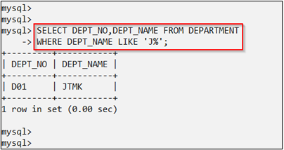

This SQL statement will match any department name that start with 'J'. Strings must be in single quotes. Or you can specify,

SELECT DEPT_NO,DEPT_NAME FROM DEPARTMENT

WHERE DEPT_NAME LIKE '%K';

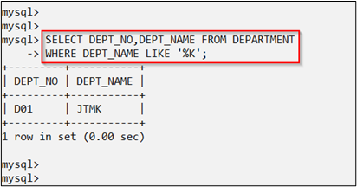

This statement will match any last names that end in a 'K'

1. ORDER BY

SELECT column_name(s) FROM table_name

ORDER BY column_name(s) ASC|DESC;

Example (REFER LAB 2):

SELECT DEPT_NO,DEPT_NAME FROM DEPARTMENT

ORDER BY DEPT_NO ASC ;

(OR)

SELECT DEPT_NO,DEPT_NAME FROM DEPARTMENT

ORDER BY DEPT_NO DESC;

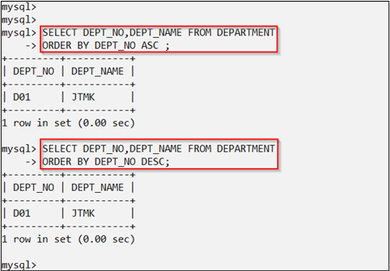

1. IN

SELECT column_name(s) FROM table_name

WHERE column_name IN (value1,value2,);

Example (REFER LAB 2):

SELECT DEPT_NO,DEPT_NAME FROM DEPARTMENT

WHERE DEPT_NAME IN ('JTMK');

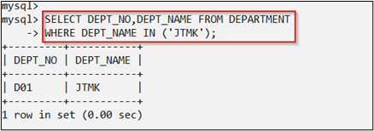

1. DISTINCT

SELECT DISTINCT column_name(s)

FROM table_name;

Example (REFER LAB 2):

SELECT DISTINCT DEPT_NO

FROM DEPARTMENT;

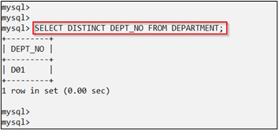

1. AND Operator

The AND operator displays a record if both the first condition and the second condition are true

Example (REFER LAB 2):

SELECT * FROM EMPLOYEE

WHERE EMP_FIRSTNAME ='AHMAD' AND EMP_LASTNAME='HAKIMI';

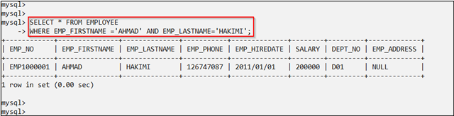

1. OR Operator

The OR operator displays a record if either the first condition or the second condition is true

Example (REFER LAB 2):

SELECT * FROM EMPLOYEE

WHERE EMP_FIRSTNAME ='AHMAD' OR EMP_LASTNAME='HAKIMI';

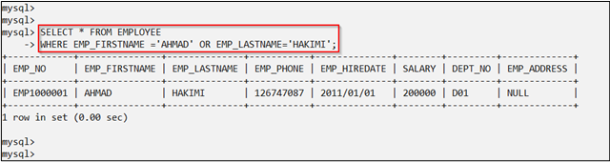

SQL JOINS

1. JOIN:

Return rows when there is at least one match in both tables

SELECT column_name(s) FROM table_name1

INNER JOIN table_name2

ON table_name1.column_name=table_name2.column_name;

**PS:**INNER JOIN is the same as JOIN

Example (REFER LAB 2):

SELECT EMPLOYEE.EMP_FIRSTNAME, EMPLOYEE.EMP_LASTNAME, DEPARTMENT.DEPT_NAME

FROM EMPLOYEE

INNER JOIN DEPARTMENT

ON EMPLOYEE.DEPT_NO=DEPARTMENT.DEPT_NO;

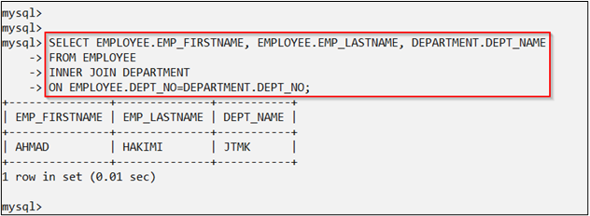

1. LEFT JOIN:

Return all rows from the left table, even if there are no matches in the right table

SELECT column_name(s) FROM table_name1

LEFT JOIN table_name2

ON table_name1.column_name=table_name2.column_name;

Example (REFER  LAB 2):

SELECT EMPLOYEE.EMP_FIRSTNAME, EMPLOYEE.EMP_LASTNAME, DEPARTMENT.DEPT_NO

FROM EMPLOYEE

LEFT JOIN DEPARTMENT

ON EMPLOYEE.DEPT_NO=DEPARTMENT.DEPT_NO;

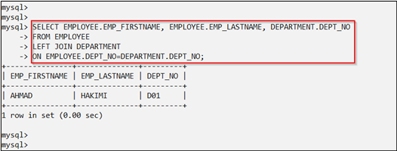

1. RIGHT JOIN:

 Return all rows from the right table, even if there are no matches in the left table

SELECT column_name(s) FROM table_name1

RIGHT JOIN table_name2

ON table_name1.column_name=table_name2.column_name;

Example (REFER LAB 2):

SELECT EMPLOYEE.EMP_FIRSTNAME, EMPLOYEE.EMP_LASTNAME, DEPARTMENT.DEPT_NO FROM EMPLOYEE RIGHT JOIN DEPARTMENT

ON EMPLOYEE.DEPT_NO=DEPARTMENT.DEPT_NO;

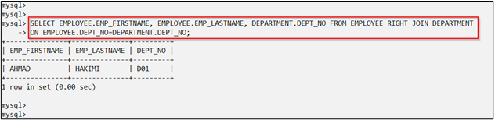

1. FULL JOIN:

Return rows when there is a match in one of the tables

SELECT column_name(s)

 FROM table_name1

FULL JOIN table_name2

ON table_name1.column_name=table_name2.column_name;

Example (REFER LAB 2):

SELECT EMPLOYEE.EMP_FIRSTNAME, EMPLOYEE.EMP_LASTNAME, DEPARTMENT.DEPT_NO

FROM EMPLOYEE

FULL JOIN DEPARTMENT

ON EMPLOYEE.DEPT_NO=DEPARTMENT.DEPT_NO;

Full join does not work in SQL server 5 instead the following query will work

SELECT EMPLOYEE.EMP_FIRSTNAME, EMPLOYEE.EMP_LASTNAME, DEPARTMENT.DEPT_NO

FROM EMPLOYEE

LEFT JOIN DEPARTMENT

ON EMPLOYEE.DEPT_NO=DEPARTMENT.DEPT_NO;

Union all

SELECT EMPLOYEE.EMP_FIRSTNAME, EMPLOYEE.EMP_LASTNAME, DEPARTMENT.DEPT_NO

FROM EMPLOYEE

RIGHT JOIN DEPARTMENT

ON EMPLOYEE.DEPT_NO=DEPARTMENT.DEPT_NO;

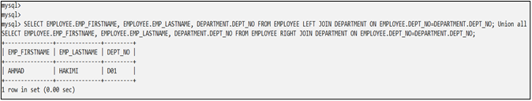

1. NESTED QUERIES:

Return rows when there is a match in one of the tables

SELECT EMP_FIRSTNAME, EMP_LASTNAME FROM EMPLOYEE

WHERE DEPT_NO IN (SELECT DEPT_NO FROM DEPARTMENT);

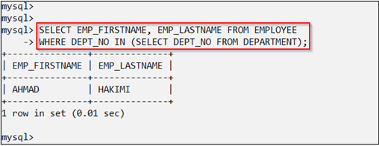

Exercise:

Refer to the tables data “**1. INSERT INTO Statement**”, answer all the below questions:-

1. Update the data in Course table from Database-to-Database Management  where CourseId is C1002
2. Delete "Logic Programming" from Subject table
3. Select only the Student from “Perak”
4. Select the Lecturer who phone num start with “014”
5. Show the OUTPUT for SQL syntax below:

Select S.StudName,C.CourseName From Student S, Course C;

Where S.CourseID=C.CourseID;

1. Show the OUTPUT for SQL syntax below:

Select S.StudName,C.CourseName,L.LectName From Student S, Course C ,Lecturer L;

Where S.CourseID=C.CourseID and C.LectID=L.LectID;

1. Select student name, subject name, grade and mark, which mark >=55
2. Write SQL syntax to show a sum of student mark for each subject
3. Write SQL syntax to show lecturer name, department name where the lecturer is from Software Engineering department